Areeb Khan (7490) Feasibility report

# Process to be followed:

# Agile Development

We will use agile development model for our project because in this process we are going to divide our work among all the members. As all the members will be responsible to their tasks so the through the agile development model all the work will be break into the sprints and the member will be provided there tasks to complete. Each member will be responsible for all the tasks given to them.

All the members will be having their time to complete their sprints so they have to complete their tasks within provided deadline.

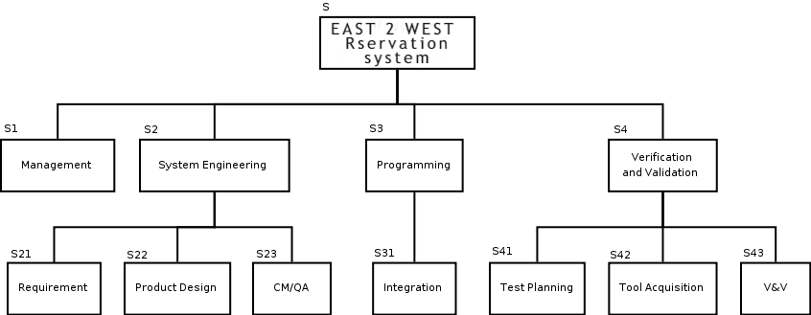**Work Breakdown Structure Of the project**

Here all the members will be given with their tasks as which they are associated to and they Will have to Complete in the provided time. Hotel reservation system is going to work as the client requirements, in this project a costumer opens a website and reserves a room in a hotel all around the globe so all the information about hotels and all the details will be added in to the project.

# Outline plan, showing principal activities and milestones.

As Project plan East 2 West reservation system, requirements are not allowed to change except through additional, contractual agreements. In addition, requirement changes do not have to be accepted after the initial 9 months of the project. Requirement changes will be accepted if contractually obligated, the changes are minor, or the changes allow a good business opportunity, all of which decided by the Project Manager.

With agile model after the competition of the task the user will be provided with the information if they wants the change during that step the changes will be made otherwise it will be moved to the other step.

Upon requirement changes, all affected documents or otherwise will be updated.

Schedule control plan

Budget control plan

Quality control plan

Reporting plan

Metrics collection plan

Risk management plan

Closeout plan

Survey

**Team Leads (Areeb Khan)**

1. Please provide some background information about your business (for example do you operate a hotel, B&B, hostel etc.) and describe the size of your business (for example the number of hotels / rooms / properties that you own and operate.

2. Please explain the different sales channels you use and their significance. For example:

• What proportion of your bookings come from Booking Websites and what proportion are made direct?

3. Please list, in the order of importance to your business, the Booking Websites that you use and explain whether this ranking has changed over the last two years.

4. What information are you required to provide in order to list your accommodation on the Booking Websites?

5. Do you provide information on pricing and room availability or the number of recent bookings and if so how often?